“Real change happens when we break down silos. HIGH-TECH HEROES shows how the next generation can bridge the gap between corporations and impact-driven startups to create solutions that truly matter.”
—James Sancto, Co-Founder & CEO, We Make Change

High-Tech Heroes positions Gen-Z as the first digital-native generation uniquely equipped to spearhead truly effective, systemic, global change.
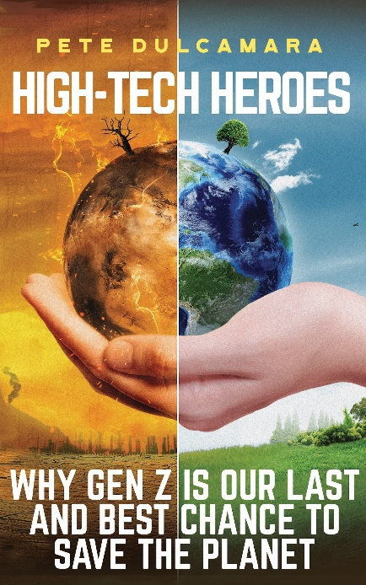
High-Tech Heroes spotlights the social change that can be driven by innovators who dare to develop products within data-driven, circular economic models. It posits the revolutionary notion of harvesting biodata extracted from disposable personal products—an idea with immeasurable potential.
High-Tech Heroes is a call to action for Gen Z to reimagine leadership, embrace transformative innovation, and leave an indelible mark on the world. This may be the last generation able to rescue Earth’s humanity from self-destruction, yet the best-equipped generation ever to try.
The book features:
- Humanity-centric Innovation: A results-driven framework that empowers leaders to align emerging technologies with business goals and social purpose, solving challenges through sustainable solutions.
- Actionable Roadmaps: Practical strategies for leveraging AI, advancing sustainability, and implementing data-driven solutions to address real challenges for immediate impact.
- AI for Sustainability and Climate Action: Using AI to predict and mitigate environmental crises, optimize resource usage, and enable the implementation of scalable, circular economies.
- Data-Driven Circular Economies: A blueprint for integrating data, technology, and sustainable concepts to completely eliminate waste, optimize planetary resources, and redefine the very concept of currency.
- Innovative Use of Biomaterials and Biodata: Methods to transform waste into valuable resources, harnessing “waste” biodata to improve health, sustainability, and industrial efficiency.

For a copy of the book, contact the publisher, Maryann Karinch, mkarinch@arminlear.com or text 970-274-1465.
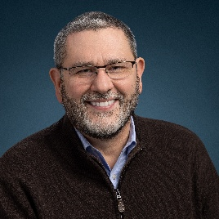
Pete Dulcamara is a globally recognized innovation strategist, speaker, and thought leader in AI, sustainability, and digital transformation. A former Chief Scientist at Kimberly-Clark and senior R&D executive at Dow Chemical, he now advises global business leaders on leveraging technology to solve humanity’s greatest challenges. His mission? To inspire a new generation to redefine success—not by wealth, but by improving lives.

